Jake Lucic

2103435  AI for Games

Spike report lab 06.2 (T7)

**Number:** Lab 06 Spike 2

**Spike Title:** Emergent Group Behaviour

**Personal:** Jake Lucic (2103435)

**Goals:**

Create a group agent steering behaviour simulation that is able to demonstrate distinct modes of emergent group behaviour. In particular, the simulation must:

• Include cohesion, separation and alignment steering behaviours

• Include basic wandering behaviours

• Use weighted-sum to combine all steering behaviours

• Support the adjustment of parameters for each steering force while running

**Technologies, Tools, and Resources used:**

In this task, the technologies used are listed below:

* Lab 06 base code from lab task 06.1
* Python IDLE v3.6.4 / Python language or PyCharm IDE
* AI for Games Lecture material

**Tasks undertaken:**

* Read the code base and understand what each function does
* Study the different key words and variable names
* Read the Lecture notes and watch lecture, gathering knowledge on cohesion, separation and alignment steering behaviours
* Understand key press behaviours and modifiers in pyglet, for easy access to changing parameters
* Add in ‘neighbourhood mode’ for bot on button click, with changeable radius
* Add cohesion, alignment, separation modes that act on a changeable value, that you can adjust in game.
* Create a weighted sum function that if in neighbourhood mode, all 3 steering behaviours calculate and operate
* Draw the values of each parameter to screen

**CODE SNIPPETS**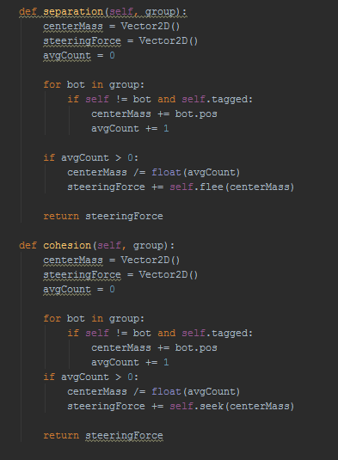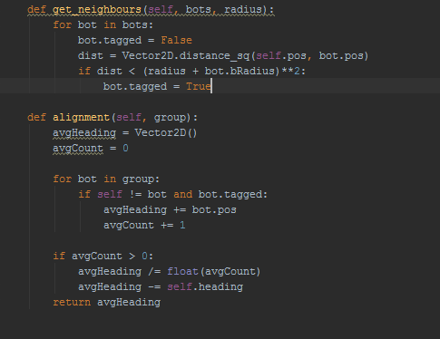

**These are the bot functions for each of the steering behaviours, including the get_neighbours function that checks if the bot has any close by friends to steer with.**

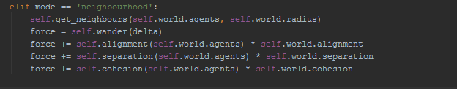**This is the weighted sum that adds the force of all 3 steering behaviours**

**CONTROLS**

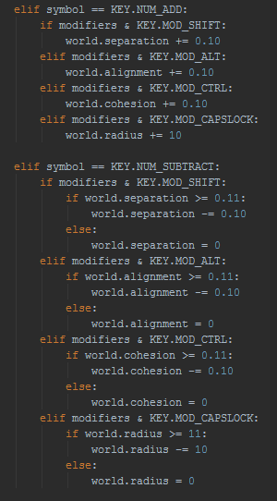A big help to making the controls function easier was to read about pyglets keyboard clicks and modifiers.

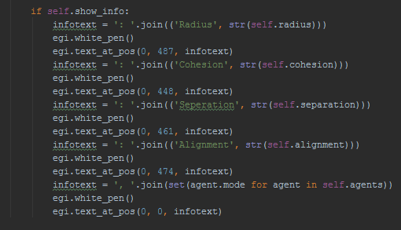

Looking at how the infotext agent.mode was written, I was able to figure out how to draw the parameters on screen.